
DIGNITY AT WORK POLICY

Repton Parish Council believes that civility and respect are important in the working environment, and expect all councillors, officers and the public to be polite and courteous when working for, and with the council.

Purpose
Repton Parish Council is committed to creating a working environment where all council employees, councillors, contractors and others who come into contact with us in the course of our work, are treated with dignity, respect and courtesy. We aim to create a workplace where there is zero tolerance for harassment and bullying

We recognise that there is a continuum where unaddressed issues have the potential to escalate and become larger, more complex issues and this policy sets out how concerns will be managed however the emphasis of this policy is on resolution and mediation where appropriate, rather than an adversarial process.

This document:
- explains how we will respond to complaints of bullying or harassment;
- ensures that we respond sensitively and promptly; and,
- supports our employees in ensuring their behaviour does not amount to bullying and/or harassment by giving examples.

Scope
This policy covers bullying and harassment of and by clerks and all employees engaged to work at Repton Parish Council. Should agency staff, or contractors have a complaint connected to their engagement with Repton Parish Council this should be raised to their nominated contact, manager, or the Chairmanman of the Council, in the first instance. Should the complaint be about the chairmanman of the council the complaint should be raised to the deputy chairmanman.
Agency staff, or contractors are equally expected to treat council colleagues, and other representatives and stakeholders with dignity and respect, and the council may terminate the contract, without notice, where there are suspicions of harassment or bullying.
Complaints about other employment matters will be managed under the council’s grievance policy.
It is noted that the management of a situation may differ depending on who the allegations relate to (e.g. employees, contractor, councillor), however, the council will take appropriate action if any of its employees are bullied or harassed by employees, councillors, members of the public, suppliers or contractors.

The position on bullying and harassment
All staff and council representatives are entitled to dignity, respect and courtesy within the workplace and to not experience any form of discrimination. Repton Parish Council will not tolerate bullying or harassment in our workplace or at work-related events outside of the workplace, whether the conduct is a one-off act or repeated course of conduct, and whether harm is intended or not. Neither will we tolerate retaliation against, or victimisation of, any person involved in bringing a complaint of harassment or bullying. You should also be aware that, if you have bullied or harassed someone (e.g. physical violence, harassment), in some circumstances the treatment may amount to a crime punishable by a fine or imprisonment.

We expect all representatives of the council to treat each other with respect and uphold the values of the code of conduct, civility and respect pledge, equality opportunities policy, and all other policies and procedures set by the Council.

We expect you to demonstrate respect by listening and paying attention to others, having consideration for other people’s feelings, following protocols and rules, showing appreciation and thanks, and being kind.

Allegations of bullying and harassment will be treated seriously. Investigations will be carried out promptly, sensitively and, as far as possible, confidentially. See the grievance policy for further details regarding the process. Employees and others who make allegations of bullying or harassment in good faith will not be treated less favourably as a result.

False accusations of harassment or bullying can have a serious effect on innocent individuals. Staff and others have a responsibility not to make false allegations. While we will assume that all complaints of bullying and harassment are made in good faith, in the event that allegations are found to be malicious or vexatious the person raising the complaint may be subject to action under the council’s disciplinary procedure.

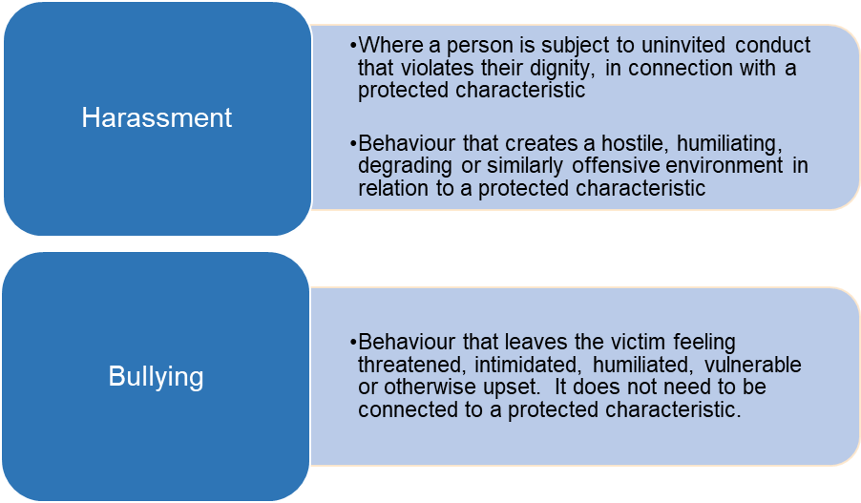

What Type of Treatment amounts to Bullying or Harassment?
‘Bullying’ or ‘harassment’ are phrases that apply to treatment from one person (or a group of people) to another that is unwanted and that has the effect of violating that person’s dignity or creating an intimidating, hostile, degrading, humiliating, or offensive environment for that person.

Examples of bullying and harassment include:
- Physical conduct ranging from unwelcome touching to serious assault
- Unwelcome sexual advances
- The offer of rewards for going along with sexual advances e.g. promotion, access to training
- Threats for rejecting sexual advances
- Demeaning comments about a person’s appearance
- Verbal abuse or offensive comments, including jokes or pranks related to age, disability, gender re-assignment, marriage, civil partnership, pregnancy, maternity, race, religion, belief, sex or sexual orientation
- Unwanted nicknames, especially related to a person's age, disability, gender re-assignment, marriage, civil partnership, pregnancy, maternity, race, religion, belief, sex or sexual orientation
- Spreading malicious rumours or insulting someone
- Lewd or suggestive comments or gestures
- Deliberate exclusion from conversations, work activities or social activities.
- Withholding information a person needs in order to do their job
- Practical jokes, initiation ceremonies or inappropriate birthday rituals
- Physical abuse such as hitting, pushing or jostling
- Rifling through, hiding or damaging personal property
- Display of pictures or objects with sexual or racial overtones, even if not directed at any particular person
- Isolation or non-cooperation at work
- Subjecting a person to humiliation or ridicule, belittling their efforts, whether directly and / or in front of others
- The use of obscene gestures
- Abusing a position of power

Bullying and harassment can occur through verbal and face to face interactions, but can also take place through sharing inappropriate or offensive content in writing or via email and other electronic communications and social media.

It is important to recognise that conduct which one person may find acceptable, another may find totally unacceptable and behaviour could be harassment when the person had no intention to offend. We all have the right to determine what offends us. Some behaviour will be clear to any reasonable person that it is likely to offend – for example sexual touching. Other examples may be less clear, however, you should be aware that harassment will occur if behaviour continues after the recipient has advised you that the behaviour is unacceptable to them.

Harassment can also occur where the unwanted behaviour relates to a perceived characteristic (such as offensive jokes or comments based on the assumption someone is gay, even if they are not) or due to their association with someone else (such as harassment related to their partner having a disability for example). See the council’s equality and diversity policy.

All employees must, therefore, treat their colleagues with respect and appropriate sensitivity and should feel able to challenge behaviour that they find offensive even if it is not directed at them.
It is important to recognise that bullying does not include appropriate criticism of an employee’s behaviour or effective, robust performance management. Constructive and fair feedback about your behaviour or performance from your manager or colleagues/Councillors is not bullying. It is part of normal employment and management routines, and should not be interpreted as anything different.

Victimisation
Victimisation is subjecting a person to a detriment because they have, in good faith, complained (whether formally or otherwise) that someone has been bullying or harassing them or someone else, or supported someone to make a complaint or given evidence in relation to a complaint. This would include isolating someone because they have made a complaint or giving them a heavier or more difficult workload.

Provided that you act in good faith, i.e. you genuinely believe that what you are saying is true, you have a right not to be victimised for making a complaint or doing anything in relation to a complaint of bullying or harassment and the council will take appropriate action to deal with any alleged victimisation, which may include disciplinary action against anyone found to have victimised you.

Making a complaint that you know to be untrue, or giving evidence that you know to be untrue, may lead to disciplinary action being taken against you.

Reporting Concerns

What you should do if you feel you are being bullied or harassed by a member of the public or supplier (as opposed to a colleague)
If you are being bullied or harassed by someone with whom you come into contact at work, please raise this with the clerk/or a councillor. Any such report will be taken seriously, and we will decide how best to deal with the situation, in consultation with you.

What you should do if you feel you are being bullied or harassed by a councillor: If you are being bullied or harassed by a councillor, please raise this with the clerk or the chairman of the council in the first instance. They will then decide how best to deal with the situation, in consultation with you. There are two possible avenues for you, informal or formal. The Informal Resolution is described below. Formal concerns regarding potential breaches of the Councillors Code of Conduct must be investigated by the Monitoring Officer.

The council will consider reasonable measures to protect your health and safety. Such measures may include a temporary change in duties or change of work location, not attending meetings with the person about whom the complaint has been made etc.

What you should do if you witness an incident you believe to harassment or bullying: If you witness such behaviour you should report the incident in confidence to the clerk or a councillor. Such reports will be taken seriously and will be treated in strict confidence as far as it is possible to do so.

What you should do if you are being bullied or harassed by another member of staff: If you are being bullied or harassed by a colleague or contractor, there are two possible avenues for you, informal or formal. These are described below.

Informal resolution
If you are being bullied or harassed, you may be able to resolve the situation yourself by explaining clearly to the perpetrator(s) that their behaviour is unacceptable, contrary to the council’s policy and must stop. Alternatively, you may wish to ask the clerk or a councillor to put this on your behalf or to be with you when confronting the perpetrator(s).
If the above approach does not work or if you do not want to try to resolve the situation in this way, you should raise the issue with the chairman of the council. (If your concern relates to the chairman, you should raise it with the vice chairman). The chairman (or another appropriate person) will discuss with you the option of trying to resolve the situation informally by telling the alleged perpetrator, without prejudicing the matter, that:

- there has been a complaint that their behaviour is having an adverse effect on a member of the council staff
- such behaviour is contrary to our policy
- for employees, the continuation of such behaviour could amount to a serious disciplinary offence

It may be possible for this conversation to take place with the alleged perpetrator without revealing your name, if this is what you want. The person dealing with it will also stress that the conversation is confidential.

In certain circumstances we may be able to involve a neutral third party (a mediator) to facilitate a resolution of the problem. The chairman (or another appropriate person) will discuss this with you if it is appropriate.

If your complaint is resolved informally, the alleged perpetrator(s) will not usually be subject to disciplinary sanctions. However, in exceptional circumstances (such as extremely serious allegation or in cases where a problem has happened before) we may decide to investigate further and take more formal action notwithstanding that you raised the matter informally. We will consult with you before taking this step.

Raising a formal complaint
If informal resolution is unsuccessful or inappropriate, you can make a formal complaint about bullying and harassment through the council’s grievance procedure. You should raise your complaint to the clerk or the chairman of the council. A formal complaint may ultimately lead to disciplinary action against the perpetrator(s) where they are employed.

The clerk or the chairman of the council will appoint someone to investigate your complaint in line with the grievance policy. You will need to co-operate with the investigation and provide the following details (if not already provided):

- The name of the alleged perpetrator(s),
- The nature of the harassment or bullying,
- The dates and times the harassment or bullying occurred,
- The names of any witnesses and
- Any action taken by you to resolve the matter informally.

The alleged perpetrator(s) would normally need to be told your name and the details of your grievance in order for the issue to be investigated properly. However, we will carry out the investigation as confidentially and sensitively as possible. Where you and the alleged perpetrator(s) work in proximity to each other, we will consider whether it is appropriate to make temporary adjustments to working arrangements whilst the matter is being investigated.

Where your complaint relates to potential breaches of the Councillors Code of Conduct, these will need to be investigated by the Monitoring Officer. The council will consider any adjustments to support you in your work and to manage the relationship with the councillor the allegations relate to, while the investigation proceeds.

Investigations will be carried out promptly (without unreasonable delay), sensitively and, as far as possible, confidentially. When carrying out any investigations, we will ensure that individuals' personal data is handled in accordance with the data protection policy.

The council will consider how to protect your health and wellbeing whilst the investigation is taking place and discuss this with you. Depending on the nature of the allegations, the Investigator may want to meet with you to understand better your complaint (see the grievance policy for further information, and details of your right to be accompanied).

After the investigation, a panel will meet with you to consider the complaint and the findings of the investigation in accordance with the grievance procedure. At the meeting you may be accompanied by a fellow worker or a trade union official.

Following the conclusion of the hearing the panel will write to you to inform you of the decision and to notify you of your right to appeal if you are dissatisfied with the outcome. You should put your appeal in writing explaining the reasons why you are dissatisfied with the decision. Your appeal will be heard under the appeal process that is described in the grievance procedure.

The use of the Disciplinary Procedure
If at any stage from the point at which a complaint is raised, we believe there is a case to answer and a disciplinary offence might have been committed, we will instigate our disciplinary procedure. We will keep you informed of the outcome.

This is a non-contractual policy and procedure which will be reviewed from time to time.

Version Number | Date of Review | Revisions Made | Date of Next Review
1 | February 2023 | Supersedes previous dignity at work Policy | February 2025
1a | March 2024 | No alterations needed | March 2025
1b | February 2025 | No alterations needed | March 2026

